COP 4640 – Operating System Environments and Administration

Mike Jurendic

Eric Netland

Nicolas Martinez

Guneet Jandir

Cody Pafford

**The Lynx You Never Xpected**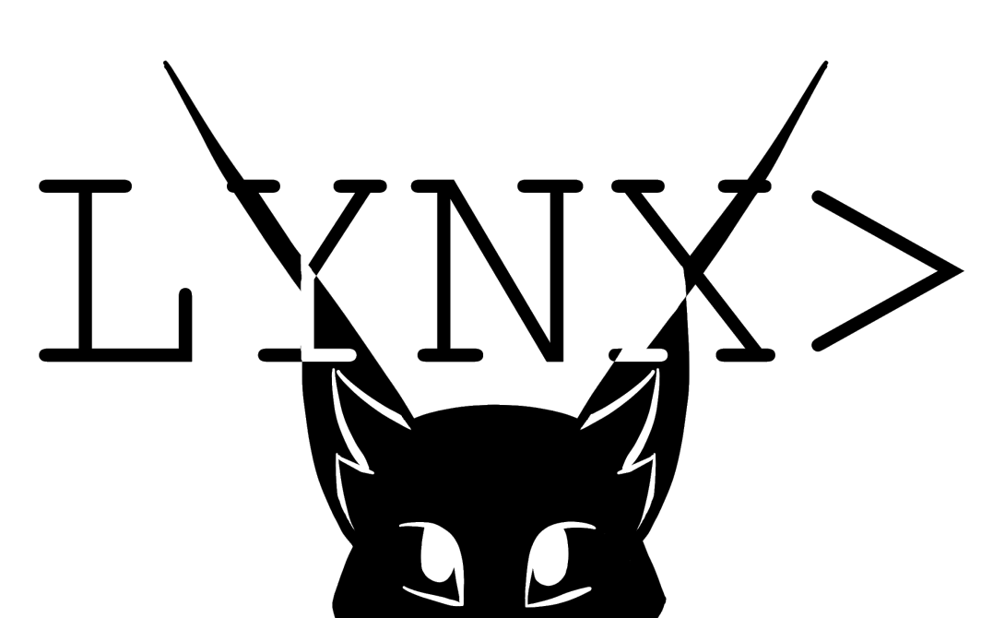

**Table of Contents**

**Research**  Page 3

**Introduction** Page 3

History and Evolution of Windows Page 4

History and Evolution of Linux Page 4

Key features of Windows 10 Page 4

Key features of Ubuntu Linux Page 5

Key Limitations of Windows 10 Page 5

Key Limitations of Ubuntu Linux Page 5

Current and Historical Market Shares Page 6

**Discussion** Page 9

Memory Management Page 9

Process Management Page 10

Concurrent Processing Page 12

Network Technologies Page 13

System Management Page 15

**Future Developments** Page 17

**Conclusion** Page 19

**References** Page 21

**Glossary** Page 26

**Biographies** Page 29

**Introduction**

**History and evolution of windows**

When it comes to operating systems, the first one that comes to most people’s minds is windows. Windows in the span of over 35 years has gone through 10 different versions from 1 to 10. Windows one came out in the year 1985, created by Bill Gates. It was Microsoft’s first attempt at a graphical user interface in 16-bit. It was notable because it relied heavy on mouse use and helped create reliance on the mouse for navigation instead of key commands. Windows 2 brought in the ability to overlap windows, the ability to minimize and maximize windows, the control panel, and Microsoft word and excel. Windows 3 was the first windows requiring the use of a hard drive and the first version to become more widely used by the public. Windows 3 brought with it the ability to run MS-DOS programs, giving it the ability to multitask legacy programs. But most importantly introduced the game Solitaire to the world. The first windows to be introduced on a CD-ROM was windows 3.1. It required at least 1MB of RAM to run and had support for mouse use in MS-DOS. In 1995 as you may have guessed it, Windows 95 was released. 95 brought with it the Start Button and Menu alongside the task bar and focused multitasking. This is also when the world's most hated web browser was released, or some call it “the google chrome downloader”. Building upon 95, windows 98 was released three years later. It came with much more software like Internet explorer, outlook, address book, and Windows Media Player. But the most important change was the windows driver model for components and accessories, the one driver support for all future versions of windows. The last windows to be based on MS-DOS was Windows ME and Windows 2000. Windows ME was meant to be more consumer friendly while 2000 was meant to be more business oriented. ME introduced important concepts to user like automated system recovery tools. But sadly, windows ME was notoriously buggy and many times failed to install properly. Windows ME was followed by possibly one of the greatest OS’s of our time, Windows XP. Windows XP did everything that ME wanted and better. It was vastly more visually appealing and developed on. XP lasted from 2001 to 2014 lasting 13 years making it the longest lasting windows ever. With its many successes it had one flaw and that was security. This led Bill Gates to start his “Trustworthy Computing” initiative and added issued service pack for XP making it more secure. XP was followed by windows vista which brought DirectX 10 giving a boost to PC gamers. Vista was not very liked by many users due to its many bugs and was quickly replaced by windows 7. Windows 7 was faster, more stable, and easier to use then vista. Due to the increased popularity of iPads and smartphones Microsoft decided to overhaul Windows. Windows 8 interface was completely changed and look more like a smartphone interface. It was made to be more touch screen friendly. Microsoft released an update to windows 8 which made it more friendly for mouse and keyboard users. Windows 8 was followed by a more keyboard and mouse friendly windows 10. Windows 10 was made to be used by both desktop users and tablet users [9].

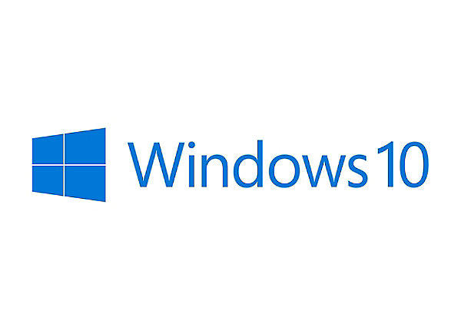**History and evolution of Linux**

Linux is also an incredibly popular operating system. Mostly because of its large support base and distribution. It was created by Linus Torvalds at the university of Helsinki while studying computer science. Linus was not happy with the MS-DOS operating system and wanted to use a UNIX based system instead but was unable to afford it. This led him to gather a group of 100 developers to create a Unix like operating system from scratch and release Linux in 1994. Linux is an open source software that developers enjoy working on and have made many improvements. Thousands of developers have contributed to the growth of Linux. This has led to the creation of Linux distributions. One such distribution is Ubuntu Linux, which was released in 2004. It is updated every six months and has support for nine months. Ubuntu has three editions desktop, server, and core editions. The desktop edition is as user friendly as windows. It comes with many different apps like Spotify, Firefox, and skype [5]. Linux started off only being popular with hobbyists and used on supercomputers but soon Dell, IBM and Hewlett-Packard started offering Linux support to curb the Windows monopoly. But Linux’s largest success may be the mobile market. The Android OS is based on the Linux kernel making it a Linux Distribution [11].

**Key Features of Windows 10**

Windows 10 offers a lot of features that provide ease of use for users. One way this is done is through their start menu which now has 2 columns and contains apps and buttons that are frequently used by the user [22]. This is a big improvement from Windows 8.1 which mostly consisted of increased touch screen functions. To assist even further, it also has a voice-controlled agent that can operate the computer through voice commands commonly referred to as Cortana [31]. This allows for increased ease of use as well as allow more people to use computers such as people who are blind. Accompanied with Cortana, Windows 10 also contains a new web browser that is integrated with the new assistant. This allows for access to the internet and its web browsers through voice. Another big new feature of Windows 10 is Virtual Desktops which allows users to create more than one desktop and switch between them on the fly. This is a new highly useful tool that adds even more quality of life changes inside of Windows 10.

**Key Features of Ubuntu Linux**

One of the great features of Ubuntu Linux is its ability to be highly customizable [29]. Just about everything can be changed, even the graphical user interface. This flexibility is what allows Linux to be changed and used across a lot of platforms and is not limited to just desktop computers or laptops. To go further into customization, Linux allows for users to control the entire base system. One reason this is possible is due to it being in modular pieces or pieces of code that are independent of each other [29]. This even allows users to interchange compilers with new ones that better suit them. Not only is it a very customizable operating system, it also runs a lot faster than other operating systems due to it being a light operating system that doesn’t require a lot of processing power.

**Key Limitations of Windows 10**

There are many great things about Windows 10, however these features come at a cost. The size of Windows 10 can range from 25GB to 40 GB. This is quite massive when compared to other operating systems like Linux which are 2GB in size. This makes it hard for Windows 10 to be on any small machinery or robots because they can’t have great enough hardware to run the operating system, let alone the programs they require to function. This limits Windows 10 to powerful devices that have leeway in resources. As mentioned before this is a major negative when resources are limited.

**Key Limitations of Ubuntu Linux**

A big disadvantage of Ubuntu Linux is that using it is very hard when compared to the highly user-friendly Windows 10. Modifying and changing Linux is a plus, but it requires the know how of the users to be at a higher level than the average Windows 10 user. Due to it not being a beefy operating system, support for modern video games on Linux is almost non-existent [19]. Entertainment is not a thing this operating system is good for. This can be attributed to it not having the best driver support out there.

**Current and Historical Market Shares**

In a world where personal computers are in every business, home, and school, operating system choice is a huge factor in how people interact with their devices. Nowadays, it is far from difficult to find personal computers that run Windows 10, considering it holds nearly 40 percent of the market share for desktop operating systems: the most of any desktop operating system on the market [17]. Windows operating systems have become a household name and it seems as though this will continue to be true for a while. Devices today such as affordable laptops are being marketed and sold with Windows 10 installed on them, which helps maintain its large market share [17]. Students and families are likely to buy these devices and become comfortable with Windows 10 since the devices it is installed on are more accessible. Despite having quite a ways to go before winning over the same number of desktop users as Windows 10, Ubuntu Linux is doing surprisingly well for itself outside of the desktop market as it takes on the cloud [30]. Ubuntu is powerful and versatile, especially for cloud deployments in large businesses including, but not limited to, Walmart, Netflix, Snapchat, and Uber [30]. Windows 10 may have a larger number of desktop users, but Ubuntu is by no means falling behind in business. Even outside the desktop market, Tianhe-2, a supercomputer project supported by funds from the Chinese government, runs Ubuntu [30]. However, the needs of the user are a large part in deciding what operating system is best for a computer, and Windows 10, following suit with its predecessors, is well-known and widespread among desktop users. Although there are far fewer supercomputers than desktop computers in the world, it says quite a lot about an operating system when it is selected to run a supercomputer!

This paper will focus on five separate sections which are important parts of an operating system. We will examine each operating system’s similarity and difference to the other to help gain a better understanding of which operating system is suitable for what situation.

***Memory Management*** starts with main memory also known as RAM. Computers are only able to make changes to data that is in main memory. Therefore, all programs and executables must be copied from a storage device into main memory to be executable. Many times, only the required part of a program is loaded into main memory. This is called Dynamic Loading, which is a technique that enhances the performance of the computer. But sometimes there is not enough main memory available to execute all currently active programs. This is where swapping comes in and takes excess processes and moves them onto a disk and brought back in when needed. Different operating systems handle memory management in different ways. We will take a look into how Windows and Linux handle memory management differently in the proposed content below.

**Process management** has a very intricate task of allocating a single Central Processing Unit (CPU) effectively among all of the system’s users and all of their jobs, processes, and threads [25]. To keep the computer running smoothly, this involves tasks such as the creation of processes, scheduling of new processes, and the termination of processes. Some computers have more than one processor (CPU) and the operating system in this case would have extra work to do to effectively manage the processes in all CPUs. However, most processors today are multi-core meaning enhanced performance, reduced power consumption and more efficient simultaneous processing of multiple tasks [36]. For example, if a computer has four cores, then it can process four sets of instructions at the same time. The process manager is responsible for handling all of this as it is a composite of at least two other sub-managers: the Job Scheduler and the Process Scheduler which is responsible for job scheduling and process scheduling, respectively. The Process Scheduler determines which processes will get the CPU, when, and for how long. The Process Scheduler relies on scheduling algorithms in an attempt to allocate the CPU in the best way possible for moving jobs in and out of the system effectively [25]. In a batch environment, we also have the influence of priority scheduling which gives priority to certain jobs that are present in the background. This guarantees that the programs with the highest priority are executed first. When people use the computer, they often think that the computer is executing multiple tasks simultaneously such as loading the photos in a browser all at once or playing a PC game while browsing the web. But what most people fail to realize is that even with a single CPU, the computer is actually doing billions of executions per second which ultimately gives the illusion of multiple processes being processed at once. However, the exact amount of executions per second would depend on the clock rate of the CPU.

***Concurrent Processing*** is a great tool that applications can use to boost their effectiveness and even solve problems more efficiently as opposed to sequentially operated applications. This is done by parallelism and is greatly enhanced by computers with multiple core processors [38]. Operating Systems play a key role in how optimal concurrent processing is because they are what provide communication between the application the cores of the processor. The two operating systems that are being compared show two different solutions to achieve the same goal. Ubuntu Linux shows that it doesn’t require much change at all and takes advantage of its unique monolithic kernel type to handle the solution, while Windows 10 uses more overhead to ensure efficient use of the devices required for execution.

***Networking Technologies*** are critical to operating systems in modern times. They allow computers using the operating system to create networks for a business like LANs, link to personal devices (PANs) and allow them to connect to the internet. Operating Systems like Linux Ubuntu and Windows 10 has built in software which implements TCP/IP protocols, ping [28].

***System Management*** is essential to ensure the efficiency of an operating system and maximal use of the resources available to it. Not all computers are used or configured in the same way, but each situation calls for a flexible framework that will allow an operating system to be effective regardless. Windows 10 and Ubuntu Linux both take a unique approach to each of the several aspects of system management, each approach exhibiting its own advantages and disadvantages. Disk management in Ubuntu, for example, is handled very differently than it is in Windows 10 [24]. The use case of each operating system sometimes determines the features it requires, which also contributes to which optimizations are supported on them. Windows 10 leverages its available hardware differently than Ubuntu Linux may, and the customization both allow the end user distinguishes the one operating system’s system management from the other. Like all modern desktop operating systems, however, both have to tackle challenges like handling virtual memory, cache memory, and system booting.

**Discussion**

**Memory Management**

The memory management system is one of the most important parts of the operating system. The most important task of the memory management system is to allocate and deallocate memory to a process. This function is executed in a similar way in Windows and Linux operating systems. This process is executed by the MMU (Memory Management Unit) which converts virtual addresses to physical addresses [1]. These addresses are created and allocated in different ways. There are many parts of memory management that achieve the same function but are executed in different ways depending on your operating system. Data structures, address space usage, paging, and page replacement are some of the way’s memory management tend to differ between the two operating systems.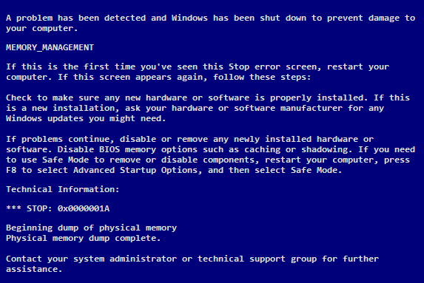

The first way we will focus on is that Windows and Linux tend to differ in the way they structure memory. Windows uses a tree data structure where each node on the tree is called a VAD (Virtual Address Descriptor). VAD’s mark each node of the tree as either free, reserved, and committed virtual memory [10]. Linux on the other hand uses a linked list data structure that maintains a list of vm_area_structs. Linux searches the vm_area_struct list whenever a page is needed, it maintains a record of the range of address and if necessary, converts the linked list into a tree data structure. Linux only converts to a tree data structure if the number of pages surpasses 32.

Another way memory is managed differently between operating systems is Address space usage. The process address space is the set of logical addresses that a process references in its code [43]. In a 32-bit system, Windows uses 2 gigabytes for the Windows kernel mode and sets 2 gigabytes aside for user space. Linux on the other hand uses only 1 gigabyte for its kernel mode and sets aside 3 gigabytes for the user [45]. This allows Linux to be more efficient than Windows. In many cases if you are using an older computer that is no longer able to handle a new version of Windows, it may be wise to go with a Linux OS to elongate the life of your computer.

Lastly paging and page replacement are another way memory management is handled differently. Paging is a memory management scheme by which a computer stores and retrieves data from secondary storage for use in main memory [7]. Virtual memory is divided into equal sized pages and is mapped to the same sized frames in physical memory. This process of mapping is handled by the MMU and is virtually the same in both operating systems. Page replacement is the part that different slightly between the two operating systems. Linux uses an LRU (Least Recently used) algorithm for its page replacement. The page that has not been used for the longest period is replaced. Linux uses a lazy swapper that only swaps in a page that is needed and nothing more, decreasing swap time and amount of memory needed. Windows uses the cluster demand paging system where instead of one page at a time a cluster of 8 pages are brought into memory. Windows uses the FIFO (First in First out) algorithm, where the oldest page is replaced. This process sufferers from the Belady’s anomaly [8]. Even though we increase the number of frames and number of page fault increases which can lead to lower performance.

**Process Management**

Scheduling algorithms usually fall into one of two categories. One being preemptive and the other being non-preemptive. A preemptive scheduling policy is a scheduling strategy that can interrupt the processing of a job and transfer the Central Processing Unit (CPU) to another job and come back to the original job later [25]. A non-preemptive scheduling policy is one that functions without any external interrupts. Therefore, once a job is started, the processor will process it until it is finished, although internal interrupts like an I/O request are allowed. Today, most operating systems use preemptive scheduling algorithms which offers more complexity but is better in most cases.

As a job, process, or thread moves through the system, its status changes, often from HOLD, to READY, to RUNNING, to WAITING, and eventually, to FINISHED [25]. Each of these are called ‘process states’ and Linux and Windows operating systems utilize these states to track a process from start to finish. Linux has a process called the Init process and it is the mother (parent) of all processes on the system, it’s the first program that is executed when the Linux system boots up; it manages all other processes on the system [20]. Windows has a very similar structure in that it has the Winit process that helps Windows get situated when you first log in and it stays running during the entire duration of computer use. Therefore, it handles the background apps and processes that run on start-up of a Windows machine.

Before the Process Scheduler can do its job, it first must wait on a job to be selected by a high level scheduler called the Job Scheduler. The Job Scheduler selects a job from a queue of incoming jobs based on each job’s characteristics in an attempt to use the system’s resources most efficiently. The process scheduling deals with the selection of a process that exists in memory that is dictated by Linux’s scheduling policy. There are three different process classes in Linux, normal, medium, and low. If the priority of the process is very low then the CPU will use the fixed First-In-First-Out (FIFO) scheduling algorithm, and if the priority is medium, it will use the preemptive fixed Round Robin scheduling algorithm [44]. If the priority is normal then the kernel uses an O( log n) process scheduler called The Completely Fair Scheduler [18]. Its focus is on maximizing overall CPU utilization while also maximizing interactive performance. This algorithm is designed to be “fair” to every task running in the system. This means that every job or task receives an equal amount of CPU power [32].

In Windows, very similar concepts to those in Linux are implemented. Windows, like all modern operating systems, uses Round Robin as the core of its scheduling, but like Linux, it can vary depending on the priority of the process. However, in Windows 10, the operating system uses a more complex version than just a simple Round Robin in that it uses a Multi-level Feedback Queue algorithm which combines the ideas of FIFO with those of Round Robin. The Multi Level Queue is a useful scheduling algorithm in that it can divide the ready queue into different classes where each class has its own scheduling needs. This means that there can be multiple queues, each with a different priority. The operating system decides how to choose the next process based on who is up next in the highest non-empty priority queue. Furthermore, each queue only gets a certain portion of CPU time and uses it to schedule its own processes and this is called time slicing [37].

In Linux when a process terminates, it will free up the resources that process was using for reallocation and the child processes die with the parent [23]. The process exits using a _exit system call and then the parent process waits on the notification that the child has been terminated. A zombie process is a process whose execution is completed but it still has an entry in the process table. Zombie processes usually occur for child processes, as the parent process still needs to read its child’s exit status [2]. Although zombie processes don’t use any system resources, they still retain a process ID and if there are a lot of zombie processes, then this means that other processes can’t be run because all of the process IDs may be all taken by the excessive amount of zombie processes.

In Windows, if a process is terminated, this does not mean that the child process or any other process it has created will be terminated like it is in Linux. Upon the termination of a process, the ExitProcess function or TerminateProcess function may be called. If the TerminateProcess function is called, then all the threads of the process are terminated immediately with no chance to run additional code. When a process terminates, the state of the process object becomes signaled, releasing any threads that had been waiting for the process to terminate [26]. This is the gist of the differences between the way Linux and Windows 10 handles the termination of processes.

**Concurrent Processing**

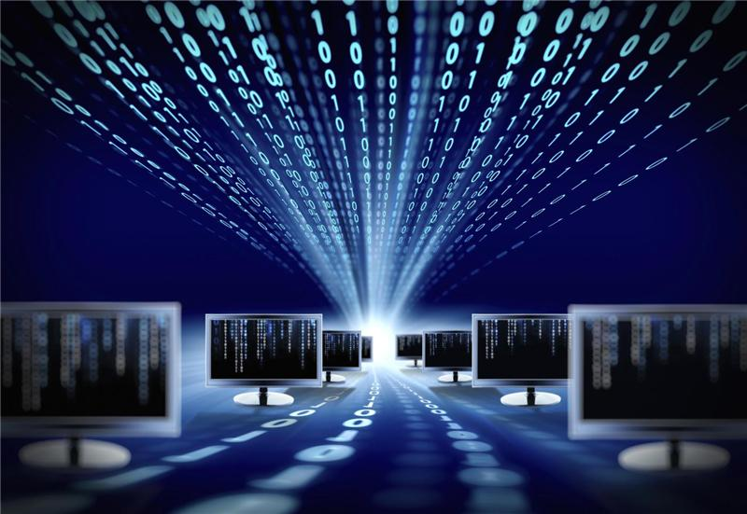For operating systems to operate in a smooth and fast manner while attending to all the tasks at hand, one way they do this is to perform multiple tasks at one time while making sure these tasks do not interfere with each other [38]. This is called concurrent processing and accomplishing this can have varying solutions depending on which operating system you choose to look at. This is very true when we look at how Windows 10 and Ubuntu Linux handle multiple tasks and how they cope with threading.

One of the key differences between the two operating systems is how their internal kernels are structured. Ubuntu Linux uses a monolithic kernel which has all parts of an operating system working inside the kernel. This inherently makes it a single large process that works within a single space [23]. This allows Linux to treat all processes the same whether they are happening at the same time or they spawn threads. Each of these processes are unique and treated as a standard process. By taking advantage of its kernel structure, Linux is able to handle threading without any extra need of help from overhead processes which allows it to be a very lightweight operating system. Unlike Linux, Windows 10 uses a hybrid kernel structure which is an attempt to get the benefits of a microkernel while having a similar structure to the monolithic kernel. This allows Windows to have global variables while also not having the operating system working in one process. Unfortunately, this type of structure does not inherently help with handling multiple processes that occur in the same timeframe.

To allow the hybrid kernel structure to be able to handle multiple processes and threading effectively, Windows 10 uses a thread manager, a program that handles the execution of all threads and synchronize the use of resources required by each process [16]. To accomplish this task, the thread manager uses various synchronization techniques that prevents hold ups such as deadlocks and starvation to occur. One example of a synchronization technique is Kernel Dispatcher Objects [14]. These objects contain other objects such as timers, events, threads, and more. A dispatcher object controls the behavior of processes by changing states from Not-Signaled to Signaled. This can be considered a type of semaphore that allows for additional control over processes to enable efficient usage of resources. Another technique used by the thread manager is spin locks which are generally used in most file systems and drivers [15]. Spin locks protect data from being accessed by multiple processes in a concurrent environment. One example of using spin locks effectively would be to prevent 2 processes to write on the same file at the same time.

These two methods showcased by Linux and Windows 10 are very different, however they are still able to achieve concurrent or parallel processing in an efficient manner. This allows these operating systems to gain the benefits of parallel processing which are the increase of reliability, flexibility, and processing speed [25]. The reliability is increased due to the hardware not having a single point of failure such as having the ability to change the allocation of resources from one CPU to another in an environment of Multiple CPUs or cores. This also ties into the increased flexibility. Being able to manage resources and change allocation enables processes to complete in a reliable and timely manner. The increased processing speed is an obvious outcome. Being able to do many things at once will save time as opposed to doing them sequentially. Speeding up the processing time will allow the operating system to handle any request of the user in a span of time that acceptable.

**Network Technologies**

Another important technology of operating systems are the networking capabilities. Network technologies are critical to the viability of an operating system. With computers becoming more and more common by the year, it is important to account for having the ability to make computers communicate with each other, whether in an office’s LAN (Local Area Network), or the Internet. The general abilities of both Linux Ubuntu servers and Windows servers are considerable for small and large businesses alike. Linux Ubuntu, being open source is highly modifiable and provides an endless amount of open source applications. Linux Ubuntu is also more resource efficient and is overall more cost effective than Windows. Despite being open source, Linux is shockingly more secure than Windows. Linux not only is less used thus making it less targeted, it also does give users admin access by default and has people constantly looking for security issues [3]. Companies only need to pay for support to install and maintain it. Windows on the other hand is more costly and not open source. However, Windows has more support included with the servers. Having Windows as your company’s server means you have better integration with Microsoft products as well [46].

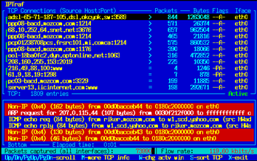

Of course, there are applications that have been developed to aid in the management of networks for Linux and Windows. Looking at Ubuntu Linux first we have applications such as Iftop. Iftop allows users to view processes involving the network in real-time, like Linux’s top command. Iptraf is another example of the many network applications that Ubuntu Linux offers. It is an application that collects a wider range of real-time information such as Transmission Control Protocol (TCP) flag info, Internet Control Messaging Protocol (ICMP) details, TCP / (User Datagram Protocol) UDP faults and more relating to network management. The big detail to keep in mind is that most of the network utility applications for Linux Ubuntu are command-line based [40]. They’re reserved for ‘power users’ given the strict nature of these kind of applications. Windows on the other hand tends to have more network applications that use a Graphical User Interface (GUI). Splunk, for one, is like Iptraf and can capture and store data from different sources [39]. Although both operating systems seem to have similar applications for network management, they seem to have the well-known difference of command-line and GUI to divide them.

To get a better idea of what operating system would be more suitable for networking, we reviewed social media posts of network/server administrators to gain a better understanding. From Quora, we have a Server Admin named Aamod Potdar. He claims the typical argument that Windows administration is easier due to GUI while with Linux you absolutely need to know the command line. However, he does mention that with Windows there is the PowerShell command line which can be used to skip the GUI and make tasks quicker and more efficient. It is not needed, but it is a big plus to those you work for [33]. A Linux Administrator on Quora, Justin Derleth, provides a deeper insight to the administration capabilities of the operating systems. It turns out that Linux is capable of GUI for the network applications, but a reason for GUI not originally being apart of the applications is the cost of the overhead on the systems. Windows tends to be inflated with software and can become cluttered on multiple devices with worries about trials, paid software and bloatware. Linux Ubuntu in a nutshell is cleaner than Windows 10 [4].

**System Management**

With all of the applications operating systems are constantly running and the devices they must interact with, there comes a need to be able to monitor and manage these devices, processes, and applications. From file systems to hard drive management, memory usage to process execution, the operating system is utilizing all of the resources it has available in the best way it can. Though Windows 10 and Ubuntu Linux may behave differently in a variety of ways, both have to handle similar issues when it comes to system management. For example, the use of virtual memory is still present in both operating systems, but both treat how it is handled configured by the user differently [48]. Ubuntu Linux allows for the user to determine the amount of “swappiness” their machine should have, which can impact system performance in a positive (or negative) way depending on the types of software the user typically runs and other system needs the user may have [12]. Windows 10 offers features as well, however, that allow the user to determine how their system utilizes resources. Despite not explicitly stating a “swappiness” for the machine, Windows 10 does enable users to modify the paging file size used [42].

Aside from just virtual memory, modern operating systems must take many other important tasks into consideration as well. Every computer has some form of hard disk or hard drive available to it which is essential to and responsible for the storage of the operating system when the machine is off and the booting of the computer when it first gets turned on. Windows 10 names each disk and distinguishes them from one another in the system’s file structure [27]. While this makes sense to Windows users and provides an easy way to know which drive is used to store certain files, Ubuntu Linux handles multiple hard disks in a different way. No matter how many drives an Ubuntu Linux user may have on their machine, they are all part of the same file structure [24].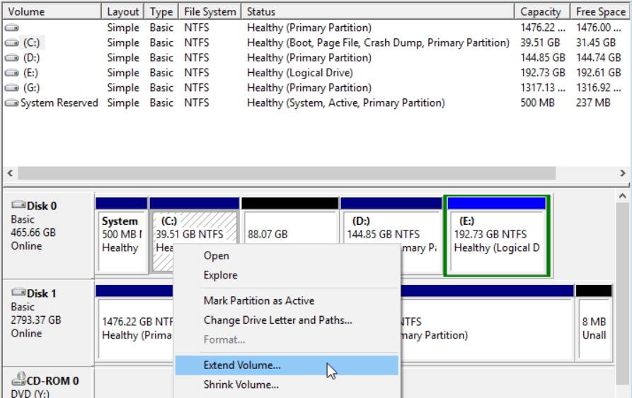

Along with hard disk management, every operating system also has to be able to handle booting up. Booting up can be a rather complicated task considering all that needs to be set up when a user turns on their machine. Because there is so much going on, it may be helpful to be able to configure how the operating system goes about booting up. In Windows 10, the Windows Boot Manager can be used to keep track of which operating system needs to be booted and from which drive it needs to be booted from [6]. Ubuntu Linux offers the same capability, but in a different package, having users modify a text file on their machine [34]. Along with just booting the entire operating system, launching software for the user also has many considerations to take into place. Sometimes users will use specific files or applications at regular intervals or immediately after booting up their machine. In order to make this process smoother, Windows 10 has “SuperFetch” that will manage resources on a user’s machine in such a way that makes booting more efficient and launching regularly used software much easier [13]. System efficiency is always at the forefront of system management for an operating system.

**Future Developments**

Currently, all major updates done on a Windows 10 computer require that the system be shut off or restarted in order to successfully update. Microsoft has mentioned an attempt at making the operating system much more modern, meaning no longer needing to restart for an update. Microsoft’s plans in summary are to improve by increasing security, enabling seamless updates, and sustained performance. In doing so, the operating system updates are invisibly done in the background. According to Nick Parker, the vice president of Microsoft, the update experience is deterministic, reliable, and instant with no interruptions [47]. If Microsoft pulls this off, then the OS can be thought of as very similar to Chrome OS. Microsoft also want this modern OS to work with 5G connectivity, and to include a variety of inputs like pen, voice, touch, and even gaze (a type of virtual technology). The next update is also rumored to include a built-in Linux kernel which will allow users to run Linux applications. Not only is Windows beginning to include a built-in Linux kernel, they are also making the system more flexible by becoming more modular with an OS called Windows Core OS. This means that if a user ever needs anything such as a new GUI, then they can add it as a module. However, this operating system is open-source and made for developers, not end-users. This advantage allows developers to implement the features and functionality the way they want them to be [35].

Being that Linux is open source, its users have a lot of influence in the evolving of the operating system. The look of the operating system will not change much in the future, as Linux has a strong mindset that the operating must be simple, yet effective.

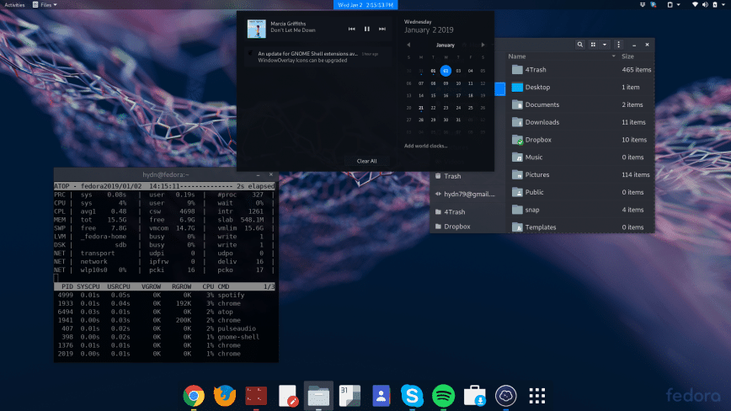

There are still a number of people who work on Linux software for their own reasons, without pay. These developers all have the same goal in mind, to create a simple, clean, and speedy operating system. This means that most Linux computers don’t have all the bells and whistles like a Windows computer would have. Linux is growing each year and currently Linux dominates all other web servers. Nearly all servers in the world run Linux or a Linux-like operating system. This is because of the many features that the OS can provide such as stability, efficiency, security, and freely-distributed source code [41]. Linux is also becoming more popular among common consumers, and it has been rumored that Linux will begin to be installed on store bought laptops. Dell already sells a Linux computer called “XPS 13 Developer Edition” that runs on Ubuntu [21]. Linux is constantly putting out updates, a few a year, that are targeted at increasing the speed. The operating system is already very fast, due to how it manages memory and processes. There is a large community of people who only use Linux based systems because of how it differs from the Windows operating system. This is why Microsoft plans on shipping a full Linux kernel in one of the next updates to attract a wider spectrum of people.

**Conclusion**

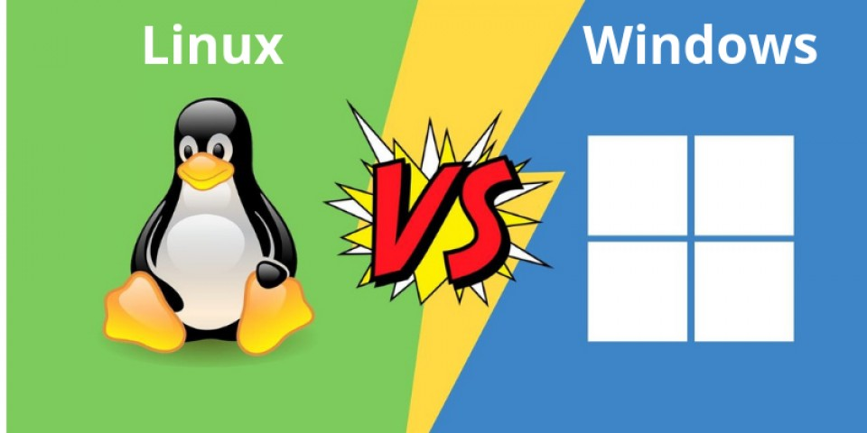

Both The Windows 10 and Linux Ubuntu Operating Systems are both regarded as useful and revolutionary. Linux began as an open-source Operating System only used by hobbyists and supercomputers. Linux embraces the free-spirited, controlled chaos of being open-source. Though it may have sounded silly at the time, Linux now has gained popularity not thought possible. Windows once had a monopoly until Linux came forth. Many large companies experimented with Linux and to this day, Linux remains a large contender with Windows. Windows however, continues to remain dominant in the personal computer market to this day. Windows embraces the ‘trustworthy-computing’ initiative set by Bill Gates. Something open-source may fail to achieve from time to time.

Windows 10 prides itself on being user-friendly with its’ emphasis on a GUI, Cortana the voice-assistant, a compact start menu and virtual desktops. It still suffers from its’ resource intensity, however. Linux Ubuntu on the other hand is an open-source alternative for experienced individuals who may wish to custom their entire operating system. Linux Ubuntu is also very lightweight and puts much less strain on hardware than Windows 10. The problem is that one must be experienced and be willing to deal with Ubuntu’s lack of user-support. It is an operating system which does not hold your hand.

As demonstrated, there are many factors to be aware of when choosing an operating system, whether it’s for personal or business use. Linux tends to manage its’ memory much better than Windows by only using algorithms such as Least Recently Used and Linked Lists. Linux only uses memory when absolutely needed. Although there is a persistent bug with zombie IDs as seen before, Linux is still widely regarded as superior in terms of speed and management of resources.

Where Linux Ubuntu and Windows 10, despite having the same Network stacks as all other operating systems, still have much different applications and ways of utilizing full network capabilities. Windows tends to, as usual, focus on user friendliness and the pretty GUI look to its’ network applications. Linux’s command-line network management applications are seemingly designed for power users and require users to know what they’re doing. Despite Linux being able to use GUI for Network applications, the main reason for the command-line preference is staying lightweight unlike Windows, which has plenty of bloatware. However, handling the system itself with Linux may be more complicated than Windows. Linux forces users to use the same file structure for all the drives on a system. Windows thankfully utilizes superfetch to make boot processes much easier on users.

The future of both these operating systems are far from bleak, and both hold promise. Windows has already given announcements on what they plan to update. Linux is open-source and therefore it is ambiguous on what comes next. However, it is still taken very seriously and is still used professionally around the globe.

Overall, both operating systems are very effective at what they’re designed to do. It is a matter of specific user requirements that should determine what individuals and businesses decide to utilize.

**References**

[1] Apriorit. 2014. Special features of Linux memory management mechanism. (November 2014). Retrieved November 21, 2019 from https://www.apriorit.com/dev-blog/209-linux-memory-management.

[2] Barnes, Ricky. 2018. What Is Zombie Process in Linux? (September 2018). Retrieved November 8, 2019 from https://www.tutorialspoint.com/what-is-zombie-process-in-linux.

[3] CBT Nuggets. 2018. Why Linux is More Secure than Windows. (January 2018). https://www.cbtnuggets.com/blog/certifications/microsoft/why-linux-is-more-secure-than-windows.

[4] Derleth, Justin. 2016. Which is better Windows admin or linux admin? (April 2016). Retrieved November 18, 2019 from <https://www.quora.com/Which-is-better-Windows-admin-or-linux-admin>.

[5] EDUCBA. 2019. Uses of Ubuntu. (August 2019). Retrieved Oct 5th, 2019 from https://www.educba.com/uses-of-ubuntu/.

[6] Fisher, Tim. 2019. What Is the Windows Boot Manager (BOOTMGR)? (March 2019). Retrieved October 1, 2019 from https://www.lifewire.com/windows-boot-manager-bootmgr-2625813.

[7] Fortuna, Andrea. 2019. Some thoughts about Windows Memory Management. (March 2019). Retrieved November 22, 2019 from https://www.andreafortuna.org/2019/03/13/some-thoughts-about-windows-memory-management/.

[8] GeeksforGeeks. 2018. Belady’s Anomaly in Page Replacement Algorithms. (August 2019). Retrieved November 5, 2019 from https://www.geeksforgeeks.org/beladys-anomaly-in-page-replacement-algorithms/.

[9] Gibbs, Samuel. 2014. From Windows 1 to Windows 10: 29 years of Windows evolution. (Oct 2014). Retrieved Oct 5th, 2019 from https://www.theguardian.com/technology/2014/oct/02/from-windows-1-to-windows-10-29-years-of-windows-evolution.

[10] Hatchostinato Project. 2019.Memory Management. (February 2019). Retrieved November 22, 2019 from https://hatchostinatoproject.com/memory-management/.

[11] HeatWare. 2014. A Brief History of Android OS. (April 2014). Retrieved Oct 3th, 2019 from https://www.heatware.net/linux-unix/brief-history-android/.

[12] Hofmann, Frank. 2018. Understanding vm.swappiness. Retrieved September 17, 2019 from https://linuxhint.com/understanding_vm_swappiness/.

[13] Holwerda, Thom. 2009. SuperFetch: How it Works & Myths. (May 2009). Retrieved September 15, 2019 from https://www.osnews.com/story/21471/superfetch-how-it-works-myths/.

[14] Hudek, Ted. 2017. Introduction to Kernel Dispatcher Objects. (June 2017). Retrieved November 19, 2019 from https://docs.microsoft.com/en-us/windows-hardware/drivers/kernel/introduction-to-kernel-dispatcher-objects.

[15] Hudek, Ted. 2017. Introduction to Spin Locks. (June 2017). Retrieved November 18, 2019 from https://docs.microsoft.com/en-us/windows-hardware/drivers/kernel/introduction-to-spin-locks.

[16] Hudek, Ted. 2018. Windows Kernel-Mode Process and Thread Manager. (October 2018). Retrieved September 16, 2019 from docs.microsoft.com/en-us/windows-hardware/drivers/kernel/windows-kernel-mode-process-and-thread-manager.

[17] Humphries, Matthew. 2019. Windows 10 Finally Becomes Most Popular Desktop OS. (January 2019). Retrieved September 29, 2019 from https://www.pcmag.com/news/365678/windows-10-finally-becomes-most-popular-desktop-os.

[18] Kalin, Marty. 2019. CFS: Completely fair process scheduling in Linux. (February 2019). Retrieved November 11, 2019 from https://opensource.com/article/19/2/fair-scheduling-linux.

[19] Khan, Ifham. 2013. Disadvantages/Advantages of Ubuntu. (October 2013). Retrieved October 3, 2019 from https://www.drawbacksof.com/disadvantages-ubuntu/.

[20] Kili, Aaron. 2017. All You Need To Know About Processes in Linux [Comprehensive Guide]. (April 2017). Retrieved September 29, 2019 from https://www.tecmint.com/linux-process-management/.

[21]Koutoupis, Petros. 2018. Review: the Dell XPS 13 Developer Edition Laptop. (November 2018). Retrieved November 8, 2019 from https://www.linuxjournal.com/content/review-dell-xps-13-developer-edition-laptop.

[22] Lambert, Joan. 2016. Microsoft Windows 10. QuickStudy Reference Guides, Boca Raton, FL.

[23] Love, Robert. 2005. Linux Kernel Process Management. (April 2005). Retrieved September 15th, 2019 from www.informit.com/articles/article.aspx?p=370047&seqNum=3.

[24] Mako Hill, Benjamin, et al. 2014. Understanding How Linux Stores and Organizes Files. (June 2014). Retrieved October 1, 2019 from http://www.informit.com/articles/article.aspx?p=2209015&seqNum=2.

[25] McIver McHoes, Ann, and Ida M Flynn. 2017. Understanding Operating Systems (8th. ed.). Cengage Learning, Boston, MA.

[26] Microsoft. 2018. Scheduling Priorities. (May 2018). Retrieved October 5, 2019 from https://docs.microsoft.com/en-us/windows/win32/procthread/scheduling-priorities.

[27] Microsoft. 2019. Overview of Disk Management. (June 2019). Retrieved October 4, 2019 from https://docs.microsoft.com/en-us/windows-server/storage/disk-management/overview-of-disk-management.

[28] Mitchell, Bradley. 2019. Operating Systems and Computer Networks. (June 2019). Retrieved October 3, 2019 from https://www.lifewire.com/operating-systems-and-computer-networks-817375.

[29] Morgan, M Gage. 2016. What are the some features of linux? (January 2016). Retrieved September 25, 2019 from www.quora.com/What-are-the-some-features-of-linux.

[30] MSV, Janakiram. 2016. 10 Reasons Why Ubuntu Is Killing It In The Cloud. (January 2016). Retrieved October 3, 2019 from https://www.forbes.com/sites/janakirammsv/2016/01/12/10-reasons-why-ubuntu-is-killing-it-in-the-cloud/#6c4813561ae5.

[31] NH Learning Solutions. 2017. Top 5 Features of Windows 10. (April 2017). Retrieved October 5, 2019 from blog.nhlearningsolutions.com/blog/top-5-features-of-windows-10.

[32] Pabla, Chandandeep Singh. 2009. Completely Fair Scheduler. (August 2009). Retrieved November 1, 2019 from https://www.linuxjournal.com/node/10267.

[33] Potdar, Aamod. 2013. Is it better to be a system administrator for Linux or for Windows systems? (November 2013). Retrieved November 12, 2019 from https://www.quora.com/Is-it-better-to-be-a-system-administrator-for-Linux-or-for-Windows-systems.

[34] Psychocats. 2012. Configuring the Boot Menu in Ubuntu. (March 2012). Retrieved September 30, 2019 from https://www.psychocats.net/ubuntu/bootmenu.

[35] Rathnam, Lavanya. 2019. Windows Core OS: What it is — and is it the future of Windows? (February 2019). Retrieved November 17, 2019 from http://techgenix.com/windows-core-os/.

[36] Rouse, Margaret and Matthew Haughn. 2019. Definition: processor (CPU). (August 2019). Retrieved September 11, 2019 from https://whatis.techtarget.com/definition/processor.

[37] Sharma Ashish. 2019. Multilevel Queue (MLQ) CPU Scheduling. (August 2019). Retrieved November 4, 2019 from https://www.geeksforgeeks.org/multilevel-queue-mlq-cpu-scheduling/.

[38] Shiono, Yasunori, et al. 2012. Efficiency of Concurrent Processing of Sort Using CSP. In 2012 13th ACIS International Conference on Software Engineering, Artificial Intelligence, Networking and Parallel/Distributed Computing. IEEE, Kyoto, Japan, 524-529. DOI: https://doi.org/10.1109/SNPD.2012.108

[39] Sohail. 2019. Best Network Monitoring Tools For Linux. (June 2019). Retrieved November 14, 2019 from http://www.linuxandubuntu.com/home/best-network-monitoring-tools-for-linux.

[40] Tabona, Andrew. 2018. The top 20 free Network Monitoring and Analysis Tools for sysadmins. (July 2018). Retrieved October 4, 2019 from https://techtalk.gfi.com/the-top-20-free-network-monitoring-and-analysis-tools-for-sys-admins/.

[41] Techopedia. 2019. Linux Server. Retrieved November 15, 2019 from https://www.techopedia.com/definition/4888/linux-server.

[42] Tom’s Hardware Community. 2018. How To Manage Virtual Memory (Pagefile) In Windows 10. (April 2018). Retrieved October 2, 2019 from https://www.tomshardware.com/news/how-to-manage-virtual-memory-pagefile-windows-10,36929.html.

[43] Tutorials Point. 2019. Operating System - Memory Management. Retrieved September 12, 2019 from https://www.tutorialspoint.com/operating_system/os_memory_management.htm.

[44] UKEssays. 2016. Compare cpu scheduling of linux and windows. (May 2016). Retrieved October 5, 2019 from https://www.ukessays.com/essays/information-systems/compare-cpu-scheduling-of-linux-and-windows.php?vref=1.

[45] UKEssays. 2019. Compare the memory management of windows with linux. (November 2019). Retrieved Oct 4th, 2019 from https://www.ukessays.com/essays/engineering/compare-the-memory-management.php.

[46] Volico. 2017. Linux vs. Microsoft Windows Servers. (April 2017). Retrieved October 2, 2019 from https://www.volico.com/linux-vs-microsoft-windows-servers/.

[47] Warren, Tom. 2019. Microsoft hints at new modern Windows OS with ‘invisible’ background updates. (May 2019). Retrieved November 8, 2019 from https://www.theverge.com/2019/5/29/18643857/microsoft-windows-lite-modern-operating-system-computex-2019-hints.

[48] Windows Support. 2017. RAM, virtual memory, pagefile, and memory management in Windows. Retrieved September 28, 2019 from https://support.microsoft.com/en-us/help/2160852/ram-virtual-memory-pagefile-and-memory-management-in-windows.

**Glossary**

* **Bélády's anomaly** - Phenomenon in which increasing the number of page frames results in an increase in the number of page faults for certain memory access patterns.
* **Central Processing Unit (CPU)** - The component with the circuitry, the chips, that controls the interpretation and execution of instructions.
* **CPU** – The component with the circuitry, the chips, that controls the interpretation and execution of instructions
* **FIFO** - A page replacement policy that removes from main memory the pages that were brought in first
* **First-In-First-Out (FIFO)** – A page replacement policy that removes from main memory the pages that were brought in first.
* **Graphical User Interface (GUI)** - An interface for users which presents visuals for user-friendliness and glamorous presentation.
* **GUI** - An interface for users which presents visuals for user-friendliness and glamorous presentation.
* **Hard Disk** - Sometimes used synonymously with the term hard drive; stores data even after the machine has been powered off.
* **Hard Drive** - Device utilized by a computer to store data even after the machine has been powered off.
* **ICMP** - A protocol in networking that deals with diagnostic tools and generating error messages when encountering issues between IP addresses.
* **Internet Control Messaging Protocol (ICMP)** - A protocol in networking that deals with diagnostic tools and generating error messages when encountering issues between IP addresses.
* **Inter-Process Communication (IPC)** - The mechanism used as shared memory in which two or more processes exchange data using memory that is commonly shared.
* **Kernel** – The part of the operating system that resides in memory at all times and performs the most essential tasks, such as managing memory and handling disk input and output
* **LAN** - Terminology for a network consisting of devices in close proximity, such as an office’s network.
* **Local Area Network (LAN)** - Terminology for a network consisting of devices in close proximity, such as an office’s network.
* **Memory Management Unit** - is a computer hardware unit having all memory references passed through itself, primarily performing the translation of virtual memory addresses to physical addresses.
* **Microkernel** - An operating system design where the operating system is split into modular parts that implement basic features.
* **Monolithic Kernel** - An operating system design where the entire operating system is working in kernel space.
* **Non-preemptive Scheduling Policy** – a job scheduling strategy that functions without external interrupts so that, once a job captures the processor and begins execution, it remains in the running state, uninterrupted, until it issues an I/O request or it is finished.
* **Overhead** - Any combination of excess or indirect computation time, memory, bandwidth, or other resources that are required to perform a specific task
* **Paging File** - A file in the Windows 10 operating system that acts as additional memory for old or inactive tasks.
* **Power User** - A more experienced user who has skills that surpass most average users.
* **Preemptive Scheduling Policy** – any process scheduling strategy that, based on predetermined policies, interrupts the processing of a job and transfers the CPU to another job.
* **Round Robin** – a preemptive scheduling policy that allocates to each job one unit of processing time per turn to ensure that the CPU is equally shared among all active processes and isn’t monopolized by any one job
* **Semaphore** - A system of sending messages that can have exactly 2 positions such as “on” or “off”.
* **SuperFetch** - A Windows 10 process that optimizes operating system and application booting.
* **Swappiness** - The parameter used to control the propensity of how likely it is for inactive tasks to be swapped out to the hard disk.
* **TCP** - A connection-oriented protocol in networking that requires connections to be established between devices. It is typically used to avoid as much data loss as possible.
* **The Completely Fair Scheduler** - is a process scheduler for the Linux kernel and is the default scheduler
* **Threading** - The act of splitting a process into multiple processes that share the same resources.
* **Transmission Control Protocol (TCP)** - A connection-oriented protocol in networking that requires connections to be established between devices. It is typically used to avoid as much data loss as possible.
* **UDP** - A connectionless protocol in networking that does not make any direct connection to addresses and is only used when speed is more important than reliability.
* **User Datagram Protocol (UDP)** - A connectionless protocol in networking that does not make any direct connection to addresses and is only used when speed is more important than reliability.
* **Virtual Address Descriptor (VAD)** - marks each node of the tree as either free, reserved, or committed virtual memory.
* **Virtual Memory** - Space on a hard drive or hard disk acting as an extension of the system’s memory typically used to temporarily store inactive tasks or processes.
* **Vm_area_struct** - A structure that describes a single memory area over a contiguous interval in a given address space.
* **Windows Boot Manager** - Software built into Windows 10 that manages installed operating systems when the machine is booting.
* **Zombie Process** - is a process that has completed execution but still has an entry in the process table: it is a process in the "Terminated state".

**Biographies**

**Eric Netland**

Currently employed as a contractor at Florida Blue, Eric Netland is an Associate IT Systems Engineer as well as a student here at the University of North Florida. Expecting a Spring 2020 graduation, Eric seeks to work with embedded systems after earning his bachelor’s degree in Computer Science.



**Nicolas Martinez**

Currently working towards a bachelors in Computer Science at the University of North Florida. I plan on graduating in Spring of 2020. My goal on future careers is to work in backend development in a stable company.



**Cody Pafford**

Currently a senior studying computer science at the University of North Florida. I am currently a software development intern at SportsMedia Technology and work primarily in Python. I plan on graduating in the Spring of 2020 and then I will begin pursuing my career as a software engineer.



**Mike Jurendic**

Currently working towards a BS in Information Technology. I expect to graduate after completing the Summer 2020 term. I aspire to work as a pentester after gaining plenty of experience in the system / network administration field. Currently I work at DuosTech as an AI trainer.

**Guneet Jandir**

Born in Punjab, India and moved to the United States at the age of five. Currently attending the University of North Florida to obtain a degree in Information Technology and is expected to graduate in the summer of 2020. I plan to work in the field of IT once my studies are completed. Currently working for Puma North America as a store supervisor in St. Augustine, responsible for communication with corporate to drive sales and marketing locally to drive foot traffic. Also ensuring associates are providing excellent customer service through coaching and encouragement.